|  |  |
| --- | --- |
| **HOME BLOOD PRESSURE CHART** | |
| Name: | Date of Birth: |
| FAO Testvale Surgery | SCAN TO NOTES OF PATIENT:  SCAN TO DOCMAN OF CLINICIAN : |
| * Measure from the upper arm using an accurate device. It is very important that your arm is supported on a table, with a small cushion if necessary and that the cuff around your arm is at the same level as your heart. * Take your blood pressure a quiet place whilst seated, wearing short sleeved or loose fitting clothing with your arm and back supported, legs uncrossed and whilst you are not talking -talking and crossed legs increase blood pressure. * Always use the same arm. * Take two readings, at least a minute apart, morning and evening for 7 days recording the lower of the two readings onto the BP log sheet. If you need to, write any useful comments in the box provided. * Once you have completed 7 days of measurements and added your name and date of birth, please hand to your doctor or reception. | |

|  |  |  |  |  |  |  |  |  |
| --- | --- | --- | --- | --- | --- | --- | --- | --- |
|  |  | SYSTOLIC (Upper number) | DIASTOLIC (lower number) | COMMENTS |  | SYSTOLIC (Upper number) | DIASTOLIC (lower number) | COMMENTS |
| 1 | AM |  |  |  | PM |  |  |  |
| 2 | AM |  |  |  | PM |  |  |  |
| 3 | AM |  |  |  | PM |  |  |  |
| 4 | AM |  |  |  | PM |  |  |  |
| 5 | AM |  |  |  | PM |  |  |  |
| 6 | AM |  |  |  | PM |  |  |  |
| 7 | AM |  |  |  | PM |  |  |  |
| AVERAGE | AM |  |  |  | PM |  |  |  |
| COMMENTS: | | | | | | | | |

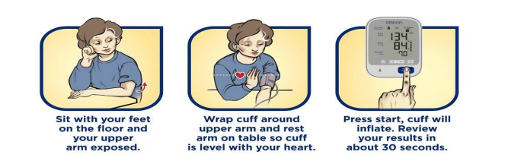

**Blood Pressure Targets**

|  |  |
| --- | --- |
| Primary Hypertension | ≤ 140/90 (≤ 135/85 HBPM)  If aged over 80 years: ≤ 150/90 |
| CVD | ≤ 140/90 |
| Diabetes | ≤ 140/80  If eye, kidney or cerebrovascular complications: ≤ 130/80 |
| CKD | 120 – 139/≤ 90 If ACR ≥70: 120 – 129/≤ 80 |